Kumaran Systems Inc.



**Jenkins Configuration Document**

Table of Contents

1. Introduction 2

2. Configuration Steps 2

# 1. Introduction

**Jenkins** is an open-source continuous integration software tool written in the Java programming language for testing and reporting on isolated changes in a larger code base in real time. The software enables developers to find and solve defects in a code base rapidly and to automate testing of their builds.

# 2. Configuration Steps

Step 1: Download the jenkins war file

Step 2: Run the jenkins via comand prompt/Shell script

**java -jar jenkins.war**

Step 3: Create a new job in jenkins dashboard by clicking New Item

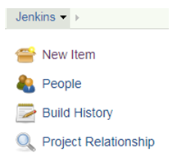

Step 4: Select Maven Project

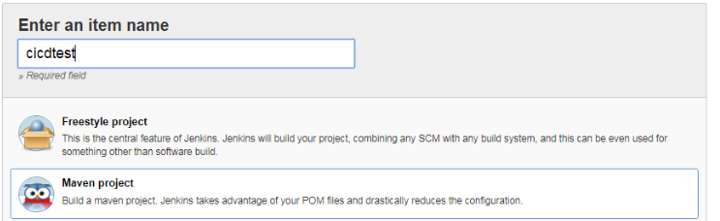

Step 5: Define repository URL , credentials and GitLab Tokens in project source code management.

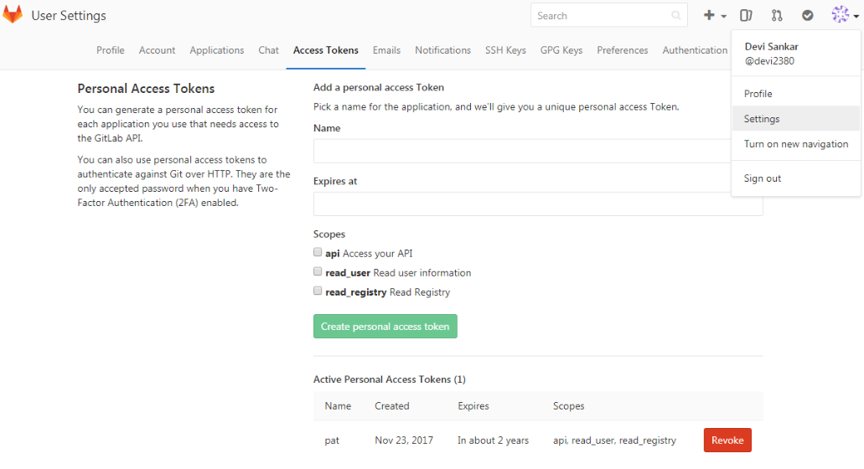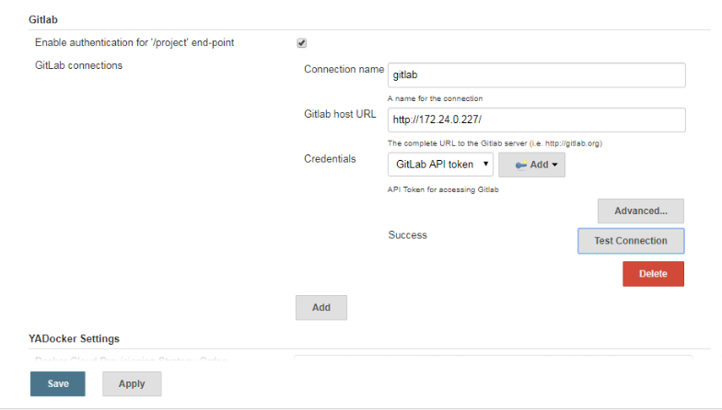

Step 6: Define Webhooks in Gitlab

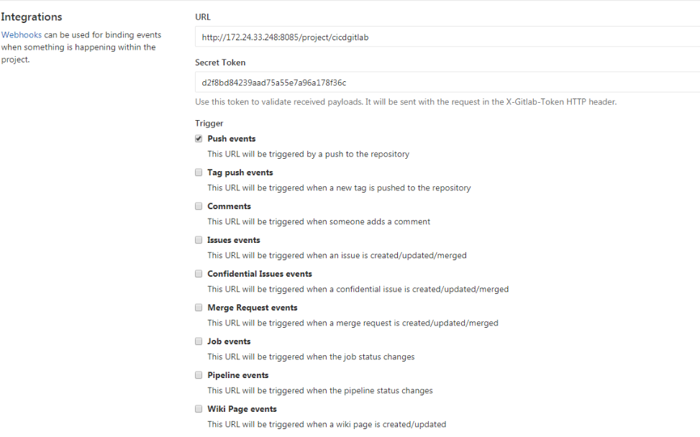

Step 7: Configure Build triggers in Jenkins.

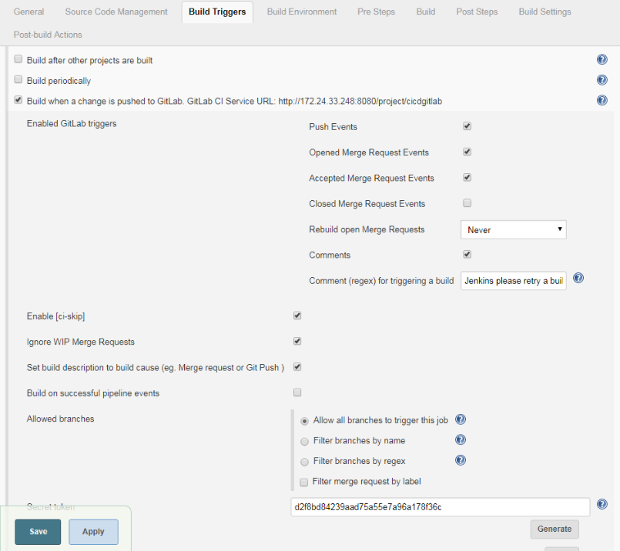

Step 8: Define Docker install path:

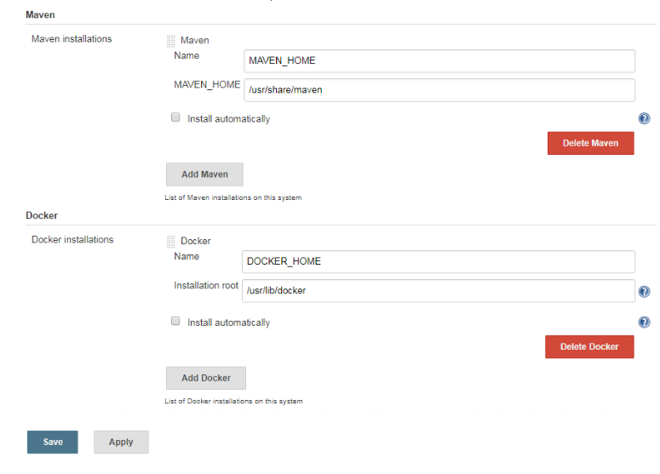

Step 9: Define Docker config:

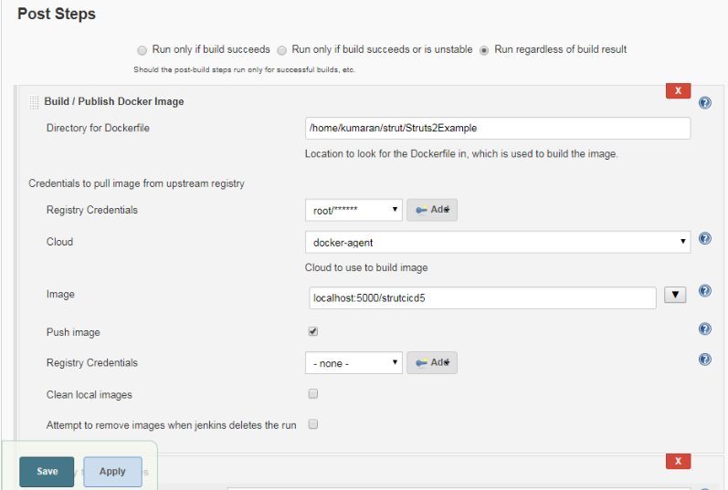

Step 10: Define Docker Agents

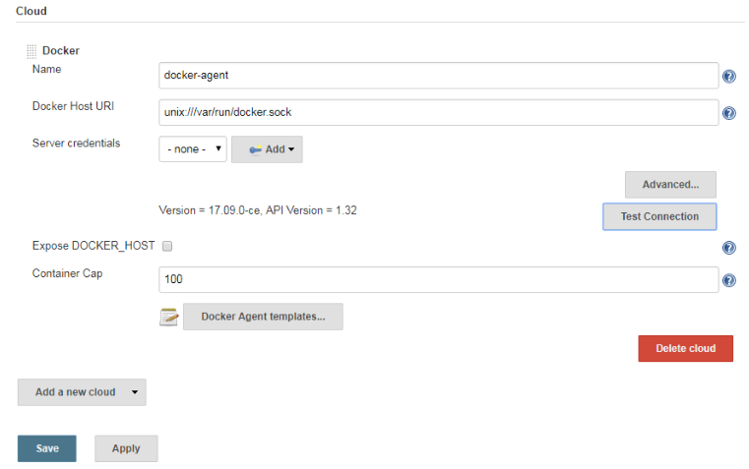

Step 11 : Define Docker Builder

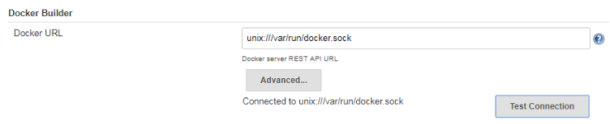

Step 12: Configure kubernetes credentials

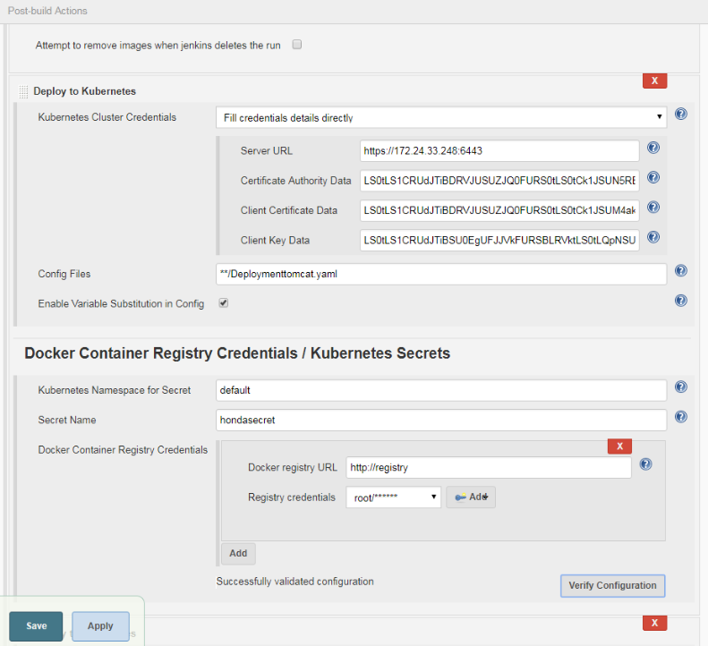

Step 13: click apply and save

# 